**CEREAL DATA ANALYSIS USING MYSQL**

**1. DATASET**

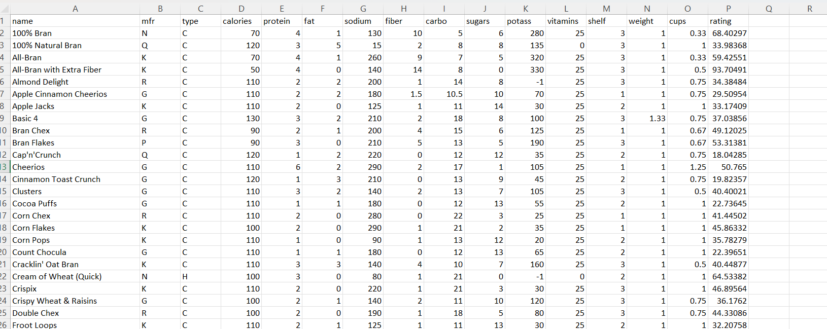

**2. DATA MIGRATION**

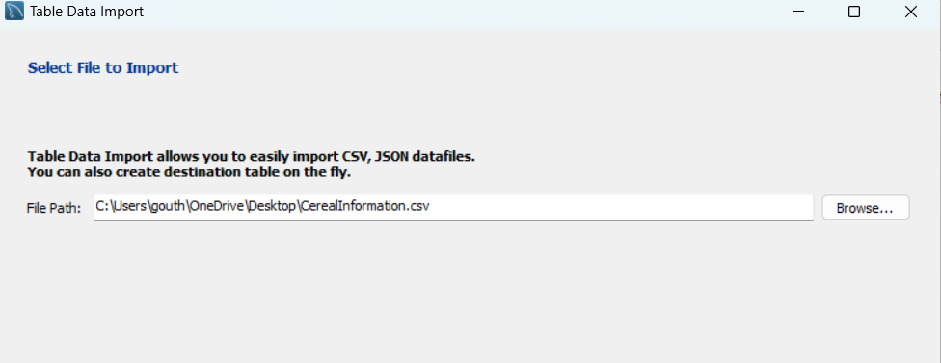

**3. DATABASE STRUCTURE**

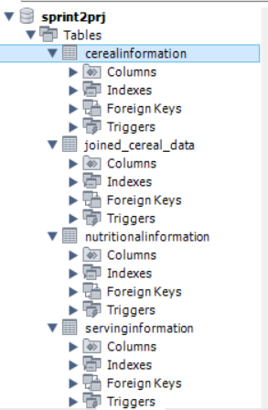

**4. EER DIAGRAM**

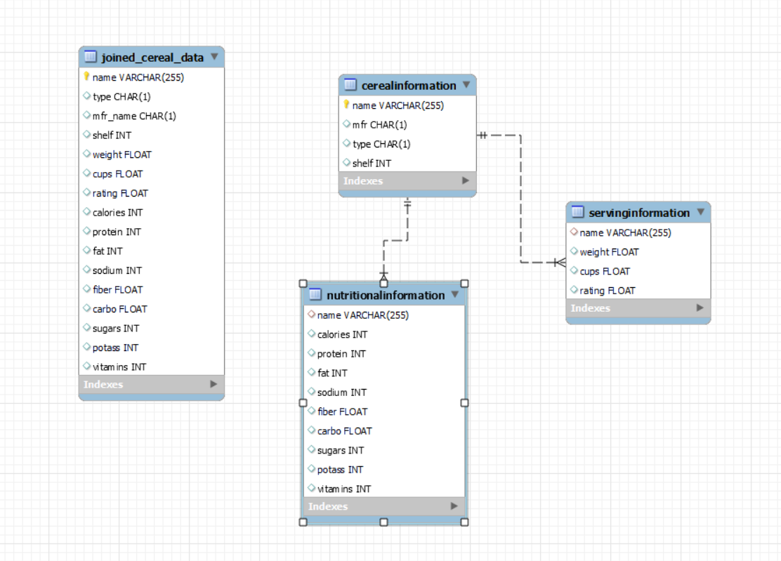

**5. SQL COMMANDS**

**mysql> use sprint2prj;**

**Database changed**

**mysql> show tables;**

**+------------------------+**

**| Tables_in_sprint2prj |**

**+------------------------+**

**| cerealinformation |**

**| joined_cereal_data |**

**| nutritionalinformation |**

**| servinginformation |**

**+------------------------+**

**4 rows in set (0.01 sec)**

**mysql> desc cerealinformation;**

**+-------+--------------+------+-----+---------+-------+**

**| Field | Type | Null | Key | Default | Extra |**

**+-------+--------------+------+-----+---------+-------+**

**| name | varchar(255) | NO | PRI | NULL | |**

**| mfr | char(1) | YES | | NULL | |**

**| type | char(1) | YES | | NULL | |**

**| shelf | int | YES | | NULL | |**

**+-------+--------------+------+-----+---------+-------+**

**4 rows in set (0.01 sec)**

**mysql> desc nutritionalinformation;**

**+----------+--------------+------+-----+---------+-------+**

**| Field | Type | Null | Key | Default | Extra |**

**+----------+--------------+------+-----+---------+-------+**

**| name | varchar(255) | YES | MUL | NULL | |**

**| calories | int | YES | | NULL | |**

**| protein | int | YES | | NULL | |**

**| fat | int | YES | | NULL | |**

**| sodium | int | YES | | NULL | |**

**| fiber | float | YES | | NULL | |**

**| carbo | float | YES | | NULL | |**

**| sugars | int | YES | | NULL | |**

**| potass | int | YES | | NULL | |**

**| vitamins | int | YES | | NULL | |**

**+----------+--------------+------+-----+---------+-------+**

**10 rows in set (0.00 sec)**

**mysql> desc servinginformation;**

**+--------+--------------+------+-----+---------+-------+**

**| Field | Type | Null | Key | Default | Extra |**

**+--------+--------------+------+-----+---------+-------+**

**| name | varchar(255) | YES | MUL | NULL | |**

**| weight | float | YES | | NULL | |**

**| cups | float | YES | | NULL | |**

**| rating | float | YES | | NULL | |**

**+--------+--------------+------+-----+---------+-------+**

**4 rows in set (0.00 sec)**

**mysql> select* from cerealinformation;**

**+----------------------------------------+------+------+-------+**

**| name | mfr | type | shelf |**

**+----------------------------------------+------+------+-------+**

**| 100% Bran | N | C | 3 |**

**| 100% Natural Bran | Q | C | 3 |**

**| All-Bran | K | C | 3 |**

**| All-Bran with Extra Fiber | K | C | 3 |**

**| Almond Delight | R | C | 3 |**

**| Apple Cinnamon Cheerios | G | C | 1 |**

**| Apple Jacks | K | C | 2 |**

**| Basic 4 | G | C | 3 |**

**| Bran Chex | R | C | 1 |**

**| Bran Flakes | P | C | 3 |**

**| Cap'n'Crunch | Q | C | 2 |**

**| Cheerios | G | C | 1 |**

**| Cinnamon Toast Crunch | G | C | 2 |**

**| Clusters | G | C | 3 |**

**| Cocoa Puffs | G | C | 2 |**

**| Corn Chex | R | C | 1 |**

**| Corn Flakes | K | C | 1 |**

**| Corn Pops | K | C | 2 |**

**| Count Chocula | G | C | 2 |**

**| Cracklin' Oat Bran | K | C | 3 |**

**| Cream of Wheat (Quick) | N | H | 2 |**

**| Crispix | K | C | 3 |**

**| Crispy Wheat & Raisins | G | C | 3 |**

**| Double Chex | R | C | 3 |**

**| Froot Loops | K | C | 2 |**

**| Frosted Flakes | K | C | 1 |**

**| Frosted Mini-Wheats | K | C | 2 |**

**| Fruit & Fibre Dates; Walnuts; and Oats | P | C | 3 |**

**| Fruitful Bran | K | C | 3 |**

**| Fruity Pebbles | P | C | 2 |**

**| Golden Crisp | P | C | 1 |**

**| Golden Grahams | G | C | 2 |**

**| Grape Nuts Flakes | P | C | 3 |**

**| Grape-Nuts | P | C | 3 |**

**| Great Grains Pecan | P | C | 3 |**

**| Honey Graham Ohs | Q | C | 2 |**

**| Honey Nut Cheerios | G | C | 1 |**

**| Honey-comb | P | C | 1 |**

**| Just Right Crunchy Nuggets | K | C | 3 |**

**| Just Right Fruit & Nut | K | C | 3 |**

**| Kix | G | C | 2 |**

**| Life | Q | C | 2 |**

**| Lucky Charms | G | C | 2 |**

**| Maypo | A | H | 2 |**

**| Muesli Raisins; Dates; & Almonds | R | C | 3 |**

**| Muesli Raisins; Peaches; & Pecans | R | C | 3 |**

**| Mueslix Crispy Blend | K | C | 3 |**

**| Multi-Grain Cheerios | G | C | 1 |**

**| Nut&Honey Crunch | K | C | 2 |**

**| Nutri-Grain Almond-Raisin | K | C | 3 |**

**| Nutri-grain Wheat | K | C | 3 |**

**| Oatmeal Raisin Crisp | G | C | 3 |**

**| Post Nat. Raisin Bran | P | C | 3 |**

**| Product 19 | K | C | 3 |**

**| Puffed Rice | Q | C | 3 |**

**| Puffed Wheat | Q | C | 3 |**

**| Quaker Oat Squares | Q | C | 3 |**

**| Quaker Oatmeal | Q | H | 1 |**

**| Raisin Bran | K | C | 2 |**

**| Raisin Nut Bran | G | C | 3 |**

**| Raisin Squares | K | C | 3 |**

**| Rice Chex | R | C | 1 |**

**| Rice Krispies | K | C | 1 |**

**| Shredded Wheat | N | C | 1 |**

**| Shredded Wheat 'n'Bran | N | C | 1 |**

**| Shredded Wheat spoon size | N | C | 1 |**

**| Smacks | K | C | 2 |**

**| Special K | K | C | 1 |**

**| Strawberry Fruit Wheats | N | C | 2 |**

**| Total Corn Flakes | G | C | 3 |**

**| Total Raisin Bran | G | C | 3 |**

**| Total Whole Grain | G | C | 3 |**

**| Triples | G | C | 3 |**

**| Trix | G | C | 2 |**

**| Wheat Chex | R | C | 1 |**

**| Wheaties | G | C | 1 |**

**| Wheaties Honey Gold | G | C | 1 |**

**+----------------------------------------+------+------+-------+**

**77 rows in set (0.00 sec)**

**mysql> select* from nutritionalinformation;**

**+----------------------------------------+----------+---------+------+--------+-------+-------+--------+--------+----------+**

**| name | calories | protein | fat | sodium | fiber | carbo | sugars | potass | vitamins |**

**+----------------------------------------+----------+---------+------+--------+-------+-------+--------+--------+----------+**

**| 100% Bran | 70 | 4 | 1 | 130 | 10 | 5 | 6 | 280 | 25 |**

**| 100% Natural Bran | 120 | 3 | 5 | 15 | 2 | 8 | 8 | 135 | 0 |**

**| All-Bran | 70 | 4 | 1 | 260 | 9 | 7 | 5 | 320 | 25 |**

**| All-Bran with Extra Fiber | 50 | 4 | 0 | 140 | 14 | 8 | 0 | 330 | 25 |**

**| Almond Delight | 110 | 2 | 2 | 200 | 1 | 14 | 8 | -1 | 25 |**

**| Apple Cinnamon Cheerios | 110 | 2 | 2 | 180 | 1.5 | 10.5 | 10 | 70 | 25 |**

**| Apple Jacks | 110 | 2 | 0 | 125 | 1 | 11 | 14 | 30 | 25 |**

**| Basic 4 | 130 | 3 | 2 | 210 | 2 | 18 | 8 | 100 | 25 |**

**| Bran Chex | 90 | 2 | 1 | 200 | 4 | 15 | 6 | 125 | 25 |**

**| Bran Flakes | 90 | 3 | 0 | 210 | 5 | 13 | 5 | 190 | 25 |**

**| Cap'n'Crunch | 120 | 1 | 2 | 220 | 0 | 12 | 12 | 35 | 25 |**

**| Cheerios | 110 | 6 | 2 | 290 | 2 | 17 | 1 | 105 | 25 |**

**| Cinnamon Toast Crunch | 120 | 1 | 3 | 210 | 0 | 13 | 9 | 45 | 25 |**

**| Clusters | 110 | 3 | 2 | 140 | 2 | 13 | 7 | 105 | 25 |**

**| Cocoa Puffs | 110 | 1 | 1 | 180 | 0 | 12 | 13 | 55 | 25 |**

**| Corn Chex | 110 | 2 | 0 | 280 | 0 | 22 | 3 | 25 | 25 |**

**| Corn Flakes | 100 | 2 | 0 | 290 | 1 | 21 | 2 | 35 | 25 |**

**| Corn Pops | 110 | 1 | 0 | 90 | 1 | 13 | 12 | 20 | 25 |**

**| Count Chocula | 110 | 1 | 1 | 180 | 0 | 12 | 13 | 65 | 25 |**

**| Cracklin' Oat Bran | 110 | 3 | 3 | 140 | 4 | 10 | 7 | 160 | 25 |**

**| Cream of Wheat (Quick) | 100 | 3 | 0 | 80 | 1 | 21 | 0 | -1 | 0 |**

**| Crispix | 110 | 2 | 0 | 220 | 1 | 21 | 3 | 30 | 25 |**

**| Crispy Wheat & Raisins | 100 | 2 | 1 | 140 | 2 | 11 | 10 | 120 | 25 |**

**| Double Chex | 100 | 2 | 0 | 190 | 1 | 18 | 5 | 80 | 25 |**

**| Froot Loops | 110 | 2 | 1 | 125 | 1 | 11 | 13 | 30 | 25 |**

**| Frosted Flakes | 110 | 1 | 0 | 200 | 1 | 14 | 11 | 25 | 25 |**

**| Frosted Mini-Wheats | 100 | 3 | 0 | 0 | 3 | 14 | 7 | 100 | 25 |**

**| Fruit & Fibre Dates; Walnuts; and Oats | 120 | 3 | 2 | 160 | 5 | 12 | 10 | 200 | 25 |**

**| Fruitful Bran | 120 | 3 | 0 | 240 | 5 | 14 | 12 | 190 | 25 |**

**| Fruity Pebbles | 110 | 1 | 1 | 135 | 0 | 13 | 12 | 25 | 25 |**

**| Golden Crisp | 100 | 2 | 0 | 45 | 0 | 11 | 15 | 40 | 25 |**

**| Golden Grahams | 110 | 1 | 1 | 280 | 0 | 15 | 9 | 45 | 25 |**

**| Grape Nuts Flakes | 100 | 3 | 1 | 140 | 3 | 15 | 5 | 85 | 25 |**

**| Grape-Nuts | 110 | 3 | 0 | 170 | 3 | 17 | 3 | 90 | 25 |**

**| Great Grains Pecan | 120 | 3 | 3 | 75 | 3 | 13 | 4 | 100 | 25 |**

**| Honey Graham Ohs | 120 | 1 | 2 | 220 | 1 | 12 | 11 | 45 | 25 |**

**| Honey Nut Cheerios | 110 | 3 | 1 | 250 | 1.5 | 11.5 | 10 | 90 | 25 |**

**| Honey-comb | 110 | 1 | 0 | 180 | 0 | 14 | 11 | 35 | 25 |**

**| Just Right Crunchy Nuggets | 110 | 2 | 1 | 170 | 1 | 17 | 6 | 60 | 100 |**

**| Just Right Fruit & Nut | 140 | 3 | 1 | 170 | 2 | 20 | 9 | 95 | 100 |**

**| Kix | 110 | 2 | 1 | 260 | 0 | 21 | 3 | 40 | 25 |**

**| Life | 100 | 4 | 2 | 150 | 2 | 12 | 6 | 95 | 25 |**

**| Lucky Charms | 110 | 2 | 1 | 180 | 0 | 12 | 12 | 55 | 25 |**

**| Maypo | 100 | 4 | 1 | 0 | 0 | 16 | 3 | 95 | 25 |**

**| Muesli Raisins; Dates; & Almonds | 150 | 4 | 3 | 95 | 3 | 16 | 11 | 170 | 25 |**

**| Muesli Raisins; Peaches; & Pecans | 150 | 4 | 3 | 150 | 3 | 16 | 11 | 170 | 25 |**

**| Mueslix Crispy Blend | 160 | 3 | 2 | 150 | 3 | 17 | 13 | 160 | 25 |**

**| Multi-Grain Cheerios | 100 | 2 | 1 | 220 | 2 | 15 | 6 | 90 | 25 |**

**| Nut&Honey Crunch | 120 | 2 | 1 | 190 | 0 | 15 | 9 | 40 | 25 |**

**| Nutri-Grain Almond-Raisin | 140 | 3 | 2 | 220 | 3 | 21 | 7 | 130 | 25 |**

**| Nutri-grain Wheat | 90 | 3 | 0 | 170 | 3 | 18 | 2 | 90 | 25 |**

**| Oatmeal Raisin Crisp | 130 | 3 | 2 | 170 | 1.5 | 13.5 | 10 | 120 | 25 |**

**| Post Nat. Raisin Bran | 120 | 3 | 1 | 200 | 6 | 11 | 14 | 260 | 25 |**

**| Product 19 | 100 | 3 | 0 | 320 | 1 | 20 | 3 | 45 | 100 |**

**| Puffed Rice | 50 | 1 | 0 | 0 | 0 | 13 | 0 | 15 | 0 |**

**| Puffed Wheat | 50 | 2 | 0 | 0 | 1 | 10 | 0 | 50 | 0 |**

**| Quaker Oat Squares | 100 | 4 | 1 | 135 | 2 | 14 | 6 | 110 | 25 |**

**| Quaker Oatmeal | 100 | 5 | 2 | 0 | 2.7 | -1 | -1 | 110 | 0 |**

**| Raisin Bran | 120 | 3 | 1 | 210 | 5 | 14 | 12 | 240 | 25 |**

**| Raisin Nut Bran | 100 | 3 | 2 | 140 | 2.5 | 10.5 | 8 | 140 | 25 |**

**| Raisin Squares | 90 | 2 | 0 | 0 | 2 | 15 | 6 | 110 | 25 |**

**| Rice Chex | 110 | 1 | 0 | 240 | 0 | 23 | 2 | 30 | 25 |**

**| Rice Krispies | 110 | 2 | 0 | 290 | 0 | 22 | 3 | 35 | 25 |**

**| Shredded Wheat | 80 | 2 | 0 | 0 | 3 | 16 | 0 | 95 | 0 |**

**| Shredded Wheat 'n'Bran | 90 | 3 | 0 | 0 | 4 | 19 | 0 | 140 | 0 |**

**| Shredded Wheat spoon size | 90 | 3 | 0 | 0 | 3 | 20 | 0 | 120 | 0 |**

**| Smacks | 110 | 2 | 1 | 70 | 1 | 9 | 15 | 40 | 25 |**

**| Special K | 110 | 6 | 0 | 230 | 1 | 16 | 3 | 55 | 25 |**

**| Strawberry Fruit Wheats | 90 | 2 | 0 | 15 | 3 | 15 | 5 | 90 | 25 |**

**| Total Corn Flakes | 110 | 2 | 1 | 200 | 0 | 21 | 3 | 35 | 100 |**

**| Total Raisin Bran | 140 | 3 | 1 | 190 | 4 | 15 | 14 | 230 | 100 |**

**| Total Whole Grain | 100 | 3 | 1 | 200 | 3 | 16 | 3 | 110 | 100 |**

**| Triples | 110 | 2 | 1 | 250 | 0 | 21 | 3 | 60 | 25 |**

**| Trix | 110 | 1 | 1 | 140 | 0 | 13 | 12 | 25 | 25 |**

**| Wheat Chex | 100 | 3 | 1 | 230 | 3 | 17 | 3 | 115 | 25 |**

**| Wheaties | 100 | 3 | 1 | 200 | 3 | 17 | 3 | 110 | 25 |**

**| Wheaties Honey Gold | 110 | 2 | 1 | 200 | 1 | 16 | 8 | 60 | 25 |**

**+----------------------------------------+----------+---------+------+--------+-------+-------+--------+--------+----------+**

**77 rows in set (0.00 sec)**

**mysql> select* from servinginformation;**

**+----------------------------------------+--------+------+---------+**

**| name | weight | cups | rating |**

**+----------------------------------------+--------+------+---------+**

**| 100% Bran | 1 | 0.33 | 68.403 |**

**| 100% Natural Bran | 1 | 1 | 33.9837 |**

**| All-Bran | 1 | 0.33 | 59.4255 |**

**| All-Bran with Extra Fiber | 1 | 0.5 | 93.7049 |**

**| Almond Delight | 1 | 0.75 | 34.3848 |**

**| Apple Cinnamon Cheerios | 1 | 0.75 | 29.5095 |**

**| Apple Jacks | 1 | 1 | 33.1741 |**

**| Basic 4 | 1.33 | 0.75 | 37.0386 |**

**| Bran Chex | 1 | 0.67 | 49.1203 |**

**| Bran Flakes | 1 | 0.67 | 53.3138 |**

**| Cap'n'Crunch | 1 | 0.75 | 18.0429 |**

**| Cheerios | 1 | 1.25 | 50.765 |**

**| Cinnamon Toast Crunch | 1 | 0.75 | 19.8236 |**

**| Clusters | 1 | 0.5 | 40.4002 |**

**| Cocoa Puffs | 1 | 1 | 22.7364 |**

**| Corn Chex | 1 | 1 | 41.445 |**

**| Corn Flakes | 1 | 1 | 45.8633 |**

**| Corn Pops | 1 | 1 | 35.7828 |**

**| Count Chocula | 1 | 1 | 22.3965 |**

**| Cracklin' Oat Bran | 1 | 0.5 | 40.4488 |**

**| Cream of Wheat (Quick) | 1 | 1 | 64.5338 |**

**| Crispix | 1 | 1 | 46.8956 |**

**| Crispy Wheat & Raisins | 1 | 0.75 | 36.1762 |**

**| Double Chex | 1 | 0.75 | 44.3309 |**

**| Froot Loops | 1 | 1 | 32.2076 |**

**| Frosted Flakes | 1 | 0.75 | 31.436 |**

**| Frosted Mini-Wheats | 1 | 0.8 | 58.3451 |**

**| Fruit & Fibre Dates; Walnuts; and Oats | 1.25 | 0.67 | 40.917 |**

**| Fruitful Bran | 1.33 | 0.67 | 41.0155 |**

**| Fruity Pebbles | 1 | 0.75 | 28.0258 |**

**| Golden Crisp | 1 | 0.88 | 35.2524 |**

**| Golden Grahams | 1 | 0.75 | 23.804 |**

**| Grape Nuts Flakes | 1 | 0.88 | 52.0769 |**

**| Grape-Nuts | 1 | 0.25 | 53.371 |**

**| Great Grains Pecan | 1 | 0.33 | 45.8117 |**

**| Honey Graham Ohs | 1 | 1 | 21.8713 |**

**| Honey Nut Cheerios | 1 | 0.75 | 31.0722 |**

**| Honey-comb | 1 | 1.33 | 28.7424 |**

**| Just Right Crunchy Nuggets | 1 | 1 | 36.5237 |**

**| Just Right Fruit & Nut | 1.3 | 0.75 | 36.4715 |**

**| Kix | 1 | 1.5 | 39.2411 |**

**| Life | 1 | 0.67 | 45.3281 |**

**| Lucky Charms | 1 | 1 | 26.7345 |**

**| Maypo | 1 | 1 | 54.8509 |**

**| Muesli Raisins; Dates; & Almonds | 1 | 1 | 37.1369 |**

**| Muesli Raisins; Peaches; & Pecans | 1 | 1 | 34.1398 |**

**| Mueslix Crispy Blend | 1.5 | 0.67 | 30.3134 |**

**| Multi-Grain Cheerios | 1 | 1 | 40.106 |**

**| Nut&Honey Crunch | 1 | 0.67 | 29.9243 |**

**| Nutri-Grain Almond-Raisin | 1.33 | 0.67 | 40.6923 |**

**| Nutri-grain Wheat | 1 | 1 | 59.6428 |**

**| Oatmeal Raisin Crisp | 1.25 | 0.5 | 30.4508 |**

**| Post Nat. Raisin Bran | 1.33 | 0.67 | 37.8406 |**

**| Product 19 | 1 | 1 | 41.5035 |**

**| Puffed Rice | 0.5 | 1 | 60.7561 |**

**| Puffed Wheat | 0.5 | 1 | 63.0056 |**

**| Quaker Oat Squares | 1 | 0.5 | 49.5119 |**

**| Quaker Oatmeal | 1 | 0.67 | 50.8284 |**

**| Raisin Bran | 1.33 | 0.75 | 39.2592 |**

**| Raisin Nut Bran | 1 | 0.5 | 39.7034 |**

**| Raisin Squares | 1 | 0.5 | 55.3331 |**

**| Rice Chex | 1 | 1.13 | 41.9989 |**

**| Rice Krispies | 1 | 1 | 40.5602 |**

**| Shredded Wheat | 0.83 | 1 | 68.2359 |**

**| Shredded Wheat 'n'Bran | 1 | 0.67 | 74.4729 |**

**| Shredded Wheat spoon size | 1 | 0.67 | 72.8018 |**

**| Smacks | 1 | 0.75 | 31.2301 |**

**| Special K | 1 | 1 | 53.1313 |**

**| Strawberry Fruit Wheats | 1 | 1 | 59.364 |**

**| Total Corn Flakes | 1 | 1 | 38.8397 |**

**| Total Raisin Bran | 1.5 | 1 | 28.5928 |**

**| Total Whole Grain | 1 | 1 | 46.6588 |**

**| Triples | 1 | 0.75 | 39.1062 |**

**| Trix | 1 | 1 | 27.7533 |**

**| Wheat Chex | 1 | 0.67 | 49.7874 |**

**| Wheaties | 1 | 1 | 51.5922 |**

**| Wheaties Honey Gold | 1 | 0.75 | 36.1876 |**

**+----------------------------------------+--------+------+---------+**

**77 rows in set (0.01 sec)**

**mysql> select* from joined_cereal_data;**

**+----------------------------------------+------+----------+-------+--------+------+---------+----------+---------+------+--------+-------+-------+--------+--------+----------+**

**| name | type | mfr_name | shelf | weight | cups | rating | calories | protein | fat | sodium | fiber | carbo | sugars | potass | vitamins |**

**+----------------------------------------+------+----------+-------+--------+------+---------+----------+---------+------+--------+-------+-------+--------+--------+----------+**

**| 100% Bran | C | N | 3 | 1 | 0.33 | 68.403 | 70 | 4 | 1 | 130 | 10 | 5 | 6 | 280 | 25 |**

**| 100% Natural Bran | C | Q | 3 | 1 | 1 | 33.9837 | 120 | 3 | 5 | 15 | 2 | 8 | 8 | 135 | 0 |**

**| All-Bran | C | K | 3 | 1 | 0.33 | 59.4255 | 70 | 4 | 1 | 260 | 9 | 7 | 5 | 320 | 25 |**

**| All-Bran with Extra Fiber | C | K | 3 | 1 | 0.5 | 93.7049 | 50 | 4 | 0 | 140 | 14 | 8 | 0 | 330 | 25 |**

**| Almond Delight | C | R | 3 | 1 | 0.75 | 34.3848 | 110 | 2 | 2 | 200 | 1 | 14 | 8 | -1 | 25 |**

**| Apple Cinnamon Cheerios | C | G | 1 | 1 | 0.75 | 29.5095 | 110 | 2 | 2 | 180 | 1.5 | 10.5 | 10 | 70 | 25 |**

**| Apple Jacks | C | K | 2 | 1 | 1 | 33.1741 | 110 | 2 | 0 | 125 | 1 | 11 | 14 | 30 | 25 |**

**| Basic 4 | C | G | 3 | 1.33 | 0.75 | 37.0386 | 130 | 3 | 2 | 210 | 2 | 18 | 8 | 100 | 25 |**

**| Bran Chex | C | R | 1 | 1 | 0.67 | 49.1203 | 90 | 2 | 1 | 200 | 4 | 15 | 6 | 125 | 25 |**

**| Bran Flakes | C | P | 3 | 1 | 0.67 | 53.3138 | 90 | 3 | 0 | 210 | 5 | 13 | 5 | 190 | 25 |**

**| Cap'n'Crunch | C | Q | 2 | 1 | 0.75 | 18.0429 | 120 | 1 | 2 | 220 | 0 | 12 | 12 | 35 | 25 |**

**| Cheerios | C | G | 1 | 1 | 1.25 | 50.765 | 110 | 6 | 2 | 290 | 2 | 17 | 1 | 105 | 25 |**

**| Cinnamon Toast Crunch | C | G | 2 | 1 | 0.75 | 19.8236 | 120 | 1 | 3 | 210 | 0 | 13 | 9 | 45 | 25 |**

**| Clusters | C | G | 3 | 1 | 0.5 | 40.4002 | 110 | 3 | 2 | 140 | 2 | 13 | 7 | 105 | 25 |**

**| Cocoa Puffs | C | G | 2 | 1 | 1 | 22.7364 | 110 | 1 | 1 | 180 | 0 | 12 | 13 | 55 | 25 |**

**| Corn Chex | C | R | 1 | 1 | 1 | 41.445 | 110 | 2 | 0 | 280 | 0 | 22 | 3 | 25 | 25 |**

**| Corn Flakes | C | K | 1 | 1 | 1 | 45.8633 | 100 | 2 | 0 | 290 | 1 | 21 | 2 | 35 | 25 |**

**| Corn Pops | C | K | 2 | 1 | 1 | 35.7828 | 110 | 1 | 0 | 90 | 1 | 13 | 12 | 20 | 25 |**

**| Count Chocula | C | G | 2 | 1 | 1 | 22.3965 | 110 | 1 | 1 | 180 | 0 | 12 | 13 | 65 | 25 |**

**| Cracklin' Oat Bran | C | K | 3 | 1 | 0.5 | 40.4488 | 110 | 3 | 3 | 140 | 4 | 10 | 7 | 160 | 25 |**

**| Cream of Wheat (Quick) | H | N | 2 | 1 | 1 | 64.5338 | 100 | 3 | 0 | 80 | 1 | 21 | 0 | -1 | 0 |**

**| Crispix | C | K | 3 | 1 | 1 | 46.8956 | 110 | 2 | 0 | 220 | 1 | 21 | 3 | 30 | 25 |**

**| Crispy Wheat & Raisins | C | G | 3 | 1 | 0.75 | 36.1762 | 100 | 2 | 1 | 140 | 2 | 11 | 10 | 120 | 25 |**

**| Double Chex | C | R | 3 | 1 | 0.75 | 44.3309 | 100 | 2 | 0 | 190 | 1 | 18 | 5 | 80 | 25 |**

**| Froot Loops | C | K | 2 | 1 | 1 | 32.2076 | 110 | 2 | 1 | 125 | 1 | 11 | 13 | 30 | 25 |**

**| Frosted Flakes | C | K | 1 | 1 | 0.75 | 31.436 | 110 | 1 | 0 | 200 | 1 | 14 | 11 | 25 | 25 |**

**| Frosted Mini-Wheats | C | K | 2 | 1 | 0.8 | 58.3451 | 100 | 3 | 0 | 0 | 3 | 14 | 7 | 100 | 25 |**

**| Fruit & Fibre Dates; Walnuts; and Oats | C | P | 3 | 1.25 | 0.67 | 40.917 | 120 | 3 | 2 | 160 | 5 | 12 | 10 | 200 | 25 |**

**| Fruitful Bran | C | K | 3 | 1.33 | 0.67 | 41.0155 | 120 | 3 | 0 | 240 | 5 | 14 | 12 | 190 | 25 |**

**| Fruity Pebbles | C | P | 2 | 1 | 0.75 | 28.0258 | 110 | 1 | 1 | 135 | 0 | 13 | 12 | 25 | 25 |**

**| Golden Crisp | C | P | 1 | 1 | 0.88 | 35.2524 | 100 | 2 | 0 | 45 | 0 | 11 | 15 | 40 | 25 |**

**| Golden Grahams | C | G | 2 | 1 | 0.75 | 23.804 | 110 | 1 | 1 | 280 | 0 | 15 | 9 | 45 | 25 |**

**| Grape Nuts Flakes | C | P | 3 | 1 | 0.88 | 52.0769 | 100 | 3 | 1 | 140 | 3 | 15 | 5 | 85 | 25 |**

**| Grape-Nuts | C | P | 3 | 1 | 0.25 | 53.371 | 110 | 3 | 0 | 170 | 3 | 17 | 3 | 90 | 25 |**

**| Great Grains Pecan | C | P | 3 | 1 | 0.33 | 45.8117 | 120 | 3 | 3 | 75 | 3 | 13 | 4 | 100 | 25 |**

**| Honey Graham Ohs | C | Q | 2 | 1 | 1 | 21.8713 | 120 | 1 | 2 | 220 | 1 | 12 | 11 | 45 | 25 |**

**| Honey Nut Cheerios | C | G | 1 | 1 | 0.75 | 31.0722 | 110 | 3 | 1 | 250 | 1.5 | 11.5 | 10 | 90 | 25 |**

**| Honey-comb | C | P | 1 | 1 | 1.33 | 28.7424 | 110 | 1 | 0 | 180 | 0 | 14 | 11 | 35 | 25 |**

**| Just Right Crunchy Nuggets | C | K | 3 | 1 | 1 | 36.5237 | 110 | 2 | 1 | 170 | 1 | 17 | 6 | 60 | 100 |**

**| Just Right Fruit & Nut | C | K | 3 | 1.3 | 0.75 | 36.4715 | 140 | 3 | 1 | 170 | 2 | 20 | 9 | 95 | 100 |**

**| Kix | C | G | 2 | 1 | 1.5 | 39.2411 | 110 | 2 | 1 | 260 | 0 | 21 | 3 | 40 | 25 |**

**| Life | C | Q | 2 | 1 | 0.67 | 45.3281 | 100 | 4 | 2 | 150 | 2 | 12 | 6 | 95 | 25 |**

**| Lucky Charms | C | G | 2 | 1 | 1 | 26.7345 | 110 | 2 | 1 | 180 | 0 | 12 | 12 | 55 | 25 |**

**| Maypo | H | A | 2 | 1 | 1 | 54.8509 | 100 | 4 | 1 | 0 | 0 | 16 | 3 | 95 | 25 |**

**| Muesli Raisins; Dates; & Almonds | C | R | 3 | 1 | 1 | 37.1369 | 150 | 4 | 3 | 95 | 3 | 16 | 11 | 170 | 25 |**

**| Muesli Raisins; Peaches; & Pecans | C | R | 3 | 1 | 1 | 34.1398 | 150 | 4 | 3 | 150 | 3 | 16 | 11 | 170 | 25 |**

**| Mueslix Crispy Blend | C | K | 3 | 1.5 | 0.67 | 30.3134 | 160 | 3 | 2 | 150 | 3 | 17 | 13 | 160 | 25 |**

**| Multi-Grain Cheerios | C | G | 1 | 1 | 1 | 40.106 | 100 | 2 | 1 | 220 | 2 | 15 | 6 | 90 | 25 |**

**| Nut&Honey Crunch | C | K | 2 | 1 | 0.67 | 29.9243 | 120 | 2 | 1 | 190 | 0 | 15 | 9 | 40 | 25 |**

**| Nutri-Grain Almond-Raisin | C | K | 3 | 1.33 | 0.67 | 40.6923 | 140 | 3 | 2 | 220 | 3 | 21 | 7 | 130 | 25 |**

**| Nutri-grain Wheat | C | K | 3 | 1 | 1 | 59.6428 | 90 | 3 | 0 | 170 | 3 | 18 | 2 | 90 | 25 |**

**| Oatmeal Raisin Crisp | C | G | 3 | 1.25 | 0.5 | 30.4508 | 130 | 3 | 2 | 170 | 1.5 | 13.5 | 10 | 120 | 25 |**

**| Post Nat. Raisin Bran | C | P | 3 | 1.33 | 0.67 | 37.8406 | 120 | 3 | 1 | 200 | 6 | 11 | 14 | 260 | 25 |**

**| Product 19 | C | K | 3 | 1 | 1 | 41.5035 | 100 | 3 | 0 | 320 | 1 | 20 | 3 | 45 | 100 |**

**| Puffed Rice | C | Q | 3 | 0.5 | 1 | 60.7561 | 50 | 1 | 0 | 0 | 0 | 13 | 0 | 15 | 0 |**

**| Puffed Wheat | C | Q | 3 | 0.5 | 1 | 63.0056 | 50 | 2 | 0 | 0 | 1 | 10 | 0 | 50 | 0 |**

**| Quaker Oat Squares | C | Q | 3 | 1 | 0.5 | 49.5119 | 100 | 4 | 1 | 135 | 2 | 14 | 6 | 110 | 25 |**

**| Quaker Oatmeal | H | Q | 1 | 1 | 0.67 | 50.8284 | 100 | 5 | 2 | 0 | 2.7 | -1 | -1 | 110 | 0 |**

**| Raisin Bran | C | K | 2 | 1.33 | 0.75 | 39.2592 | 120 | 3 | 1 | 210 | 5 | 14 | 12 | 240 | 25 |**

**| Raisin Nut Bran | C | G | 3 | 1 | 0.5 | 39.7034 | 100 | 3 | 2 | 140 | 2.5 | 10.5 | 8 | 140 | 25 |**

**| Raisin Squares | C | K | 3 | 1 | 0.5 | 55.3331 | 90 | 2 | 0 | 0 | 2 | 15 | 6 | 110 | 25 |**

**| Rice Chex | C | R | 1 | 1 | 1.13 | 41.9989 | 110 | 1 | 0 | 240 | 0 | 23 | 2 | 30 | 25 |**

**| Rice Krispies | C | K | 1 | 1 | 1 | 40.5602 | 110 | 2 | 0 | 290 | 0 | 22 | 3 | 35 | 25 |**

**| Shredded Wheat | C | N | 1 | 0.83 | 1 | 68.2359 | 80 | 2 | 0 | 0 | 3 | 16 | 0 | 95 | 0 |**

**| Shredded Wheat 'n'Bran | C | N | 1 | 1 | 0.67 | 74.4729 | 90 | 3 | 0 | 0 | 4 | 19 | 0 | 140 | 0 |**

**| Shredded Wheat spoon size | C | N | 1 | 1 | 0.67 | 72.8018 | 90 | 3 | 0 | 0 | 3 | 20 | 0 | 120 | 0 |**

**| Smacks | C | K | 2 | 1 | 0.75 | 31.2301 | 110 | 2 | 1 | 70 | 1 | 9 | 15 | 40 | 25 |**

**| Special K | C | K | 1 | 1 | 1 | 53.1313 | 110 | 6 | 0 | 230 | 1 | 16 | 3 | 55 | 25 |**

**| Strawberry Fruit Wheats | C | N | 2 | 1 | 1 | 59.364 | 90 | 2 | 0 | 15 | 3 | 15 | 5 | 90 | 25 |**

**| Total Corn Flakes | C | G | 3 | 1 | 1 | 38.8397 | 110 | 2 | 1 | 200 | 0 | 21 | 3 | 35 | 100 |**

**| Total Raisin Bran | C | G | 3 | 1.5 | 1 | 28.5928 | 140 | 3 | 1 | 190 | 4 | 15 | 14 | 230 | 100 |**

**| Total Whole Grain | C | G | 3 | 1 | 1 | 46.6588 | 100 | 3 | 1 | 200 | 3 | 16 | 3 | 110 | 100 |**

**| Triples | C | G | 3 | 1 | 0.75 | 39.1062 | 110 | 2 | 1 | 250 | 0 | 21 | 3 | 60 | 25 |**

**| Trix | C | G | 2 | 1 | 1 | 27.7533 | 110 | 1 | 1 | 140 | 0 | 13 | 12 | 25 | 25 |**

**| Wheat Chex | C | R | 1 | 1 | 0.67 | 49.7874 | 100 | 3 | 1 | 230 | 3 | 17 | 3 | 115 | 25 |**

**| Wheaties | C | G | 1 | 1 | 1 | 51.5922 | 100 | 3 | 1 | 200 | 3 | 17 | 3 | 110 | 25 |**

**| Wheaties Honey Gold | C | G | 1 | 1 | 0.75 | 36.1876 | 110 | 2 | 1 | 200 | 1 | 16 | 8 | 60 | 25 |**

**+----------------------------------------+------+----------+-------+--------+------+---------+----------+---------+------+--------+-------+-------+--------+--------+----------+**

**77 rows in set (0.00 sec)**

**mysql> desc joined_cereal_data;**

**+----------+--------------+------+-----+---------+-------+**

**| Field | Type | Null | Key | Default | Extra |**

**+----------+--------------+------+-----+---------+-------+**

**| name | varchar(255) | NO | PRI | NULL | |**

**| type | char(1) | YES | | NULL | |**

**| mfr_name | char(1) | YES | | NULL | |**

**| shelf | int | YES | | NULL | |**

**| weight | float | YES | | NULL | |**

**| cups | float | YES | | NULL | |**

**| rating | float | YES | | NULL | |**

**| calories | int | YES | | NULL | |**

**| protein | int | YES | | NULL | |**

**| fat | int | YES | | NULL | |**

**| sodium | int | YES | | NULL | |**

**| fiber | float | YES | | NULL | |**

**| carbo | float | YES | | NULL | |**

**| sugars | int | YES | | NULL | |**

**| potass | int | YES | | NULL | |**

**| vitamins | int | YES | | NULL | |**

**+----------+--------------+------+-----+---------+-------+**

**16 rows in set (0.01 sec)**

**SELECT**

**ci.name,**

**ci.type,**

**ci.mfr AS mfr_name,**

**ci.shelf,**

**si.weight,**

**si.cups,**

**si.rating,**

**ni.calories,**

**ni.protein,**

**ni.fat,**

**ni.sodium,**

**ni.fiber,**

**ni.carbo,**

**ni.sugars,**

**ni.potass,**

**ni.vitamins**

**FROM**

**cerealinformation ci**

**JOIN**

**servinginformation si ON ci.name = si.name**

**JOIN**

**nutritionalinformation ni ON ci.name = ni.name**